The collages shown below were created by students in the CS 120 course, and judged by their peers to be the best in each section of the course. Although these could have been created using an image-editing program, these students have written the code themselves to create these collages programmatically by manipulating individual pixels.

Section 1 Instructor: Vinayak Tanksale

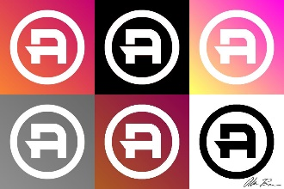
"Logo Iterations: A" by Alan Bauer
Junior; Computer Science major
Artist's statement: "When the project was announced, I set a personal goal to create a collage which respected the rules of graphic design and used a series of functions that could be reused by other designers. I found that the biggest challenge in creating my collage was aligning project guidelines with the principles of design. The most rewarding part of the collage creation project is seeing a logo that I created come to life in different color iterations through the power of Python."

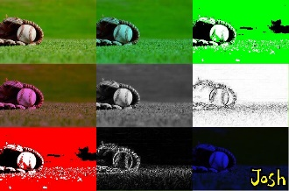
"It’s a baseball mitt" by Josh Birnbaum
Freshman; Computer Science major
Artist's statement: "The most challenging part was finding a royalty free picture that I liked. The most rewarding was getting an A."

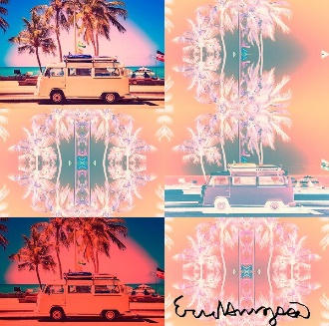
"Caravan Dreamin'" by Eric Hinojosa
Sophomore; Physics major
Artist's statement: "I found the most challenging aspect of this collage was choosing the picture I wanted to manipulate. The most rewarding part of this project was seeing the collage as a result of my code. Being able to make code that displays a collage was rewarding to me and brought about excitement that I was able to create this myself through simple coding."

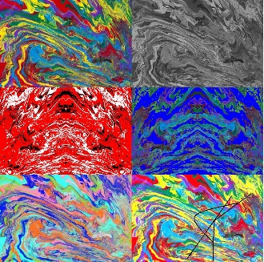
"Cam's Colors" by Cameron Keough
Freshman; Computer Science major
Artist's statement: "I found the hardest part was putting all the moving parts together, such as the sizing and the signature and format. Seeing it all come together was very rewarding—on their own, the images are alright, but seeing them all together is a lot to look at and think about."

Section 1 Instructor: Vinayak Tanksale (continued)

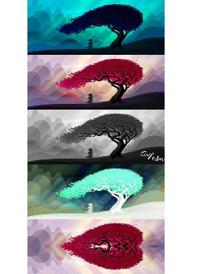
"Back to the Past" by Clay Reber
Sophomore; Computer Science major, Entrepreneurial Management minor
Artist's statement: "The most challenging part about creating my collage was making sure my images were working off the original picture, and not simply editing the picture before it. Example: My negative picture would try to use the grayscale image, and not the original photo. The most rewarding part was slowly understanding how pictures are modified in a digital space. I know that seems very simple, but it never occurred to me before how different digital art is when compared to a physical sketch or painting."

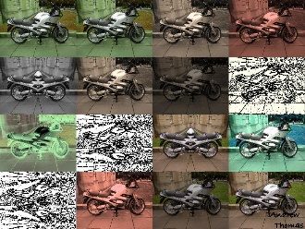
"Machine Mind" by Andrew Thomas
Freshman; Computer Science major, Mathematics and Entrepreneurial Management minors
Artist's statement: "The most challenging thing that I was successful with, was creating an algorithm that would scale down any image the amount needed for the specific layout. There were lots of variables (initial dimensions, number of pictures, number of rows, number of columns, even the layout of the collage was random 1000x726 or 726x1000) so it required a lot of time and thinking before the implementation. I found the complexity of randomness to be rewarding. When you are working with set values it’s easy to see mistakes and fix them, but when an error is only replicated 1 in a million times, the logic has to be thoroughly understood to be fixed. Whether to include the last number in a range would dramatically change the programs functionality in many places. I think it helped me develop a deeper understanding of the language."

Section 2 Instructor: Vinayak Tanksale

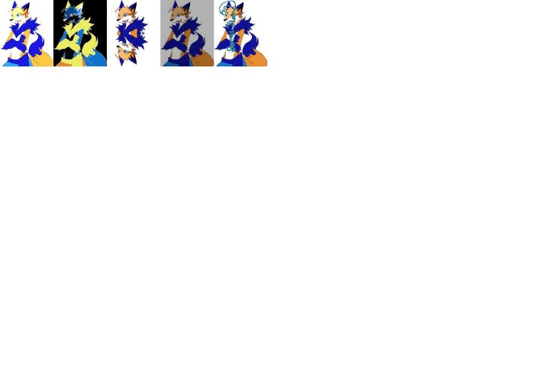
"Feurlogan" by James Dean
Freshman; Computer Science major
Artist's statement: "I found making the images show together challenging. Seeing the end result was rewarding."
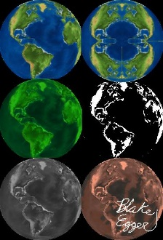
"Colors of the Earth" by Blake Egger
Freshman; Computer Science major; Japanese minor
Artist's statement: "The most challenging part of the collage was actually coming up with an idea of what to feature. The most rewarding part of the collage was clicking the run button and having the collage appear as I planned it to!"

Section 2 Instructor: Vinayak Tanksale (continued)

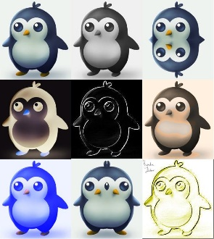
"The Psychedelic Penguins" by Kendra Furlano
Freshman; Computer Science major
Artist's statement: "I had a lot of trouble with the copy function and I had to resize my photo about 7 times. However, I am very happy with how it looked in the end, trouble or not this collage is something I will continue to be proud of, even later when I will be able to code much better. I love how well it came out despite how much trouble I had with it."

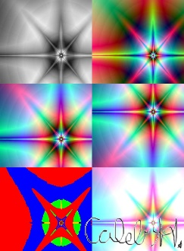
"Rainbow Star" by Caleb Horsman
Freshman; Computer Science major
Artist's statement: "The most difficult part of creating the collage was making sure that the new photos copied over to the canvas in the correct place. The most rewarding part of making the collage was finishing all the copying code. Once that was done, I was finally able to go into the pictures and modify them to how they were supposed to look."

Section 3 Instructor: David Largent

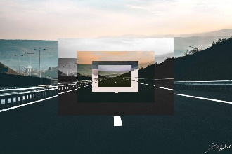
"Road to nowhere" by Kade Dentel
Freshman; Computer Science major
Artist's statement: "The most challenging piece of the project was positioning the scaled down images to where I wanted them. The most rewarding part was the aesthetic quality that I find from the collage."

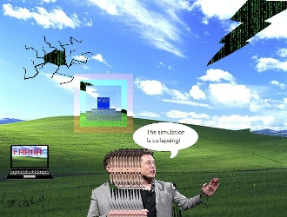
"Bliss" by Cam Dowless
Freshman; Computer Science major
Artist's statement: "The most challenging part of the project was figuring out the exact point where everything needed to go. The most rewarding part was getting Elon Musk to work. I spent a lot of time on that."

Section 3 Instructor: David Largent (continued)

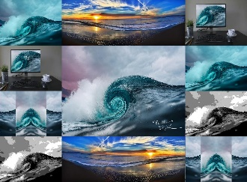
"El Mar" by Tenney Luke
Freshman; Computer Science major
Artist's statement: "By far the most difficult part of this collage was figuring out the sin and cos equations that manage the swirl effect on the center image. The most rewarding part of creating this college was being able to take boring lines of code and make them produce a cool piece of art."

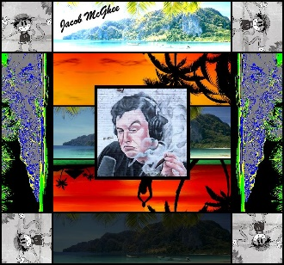
"Relax" by Jacob Mcghee
Freshman; Computer Technology major
Artist's statement: "The most challenging part was writing my own program(s) to flip/mirror an entire picture, and not from a “mirror point”. The most rewarding part of this project was putting (copying) all the pieces together and adding final touches like the lines and my signature."

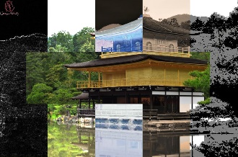
"Kinkakuji (Golden Pavilion)" by Camryn McMurtry
Freshman; Japanese major
Artist's statement: "What I found most challenging was getting the previous modifications of the picture to not copy into my next modification. The most rewarding part was the outcome of the picture."


"Kyoto" by Gail Wiley
Junior; Japanese major; Asian Studies and Computer Science minors
Artist's statement: "The most difficult part of creating this collage was getting the kanji (the Japanese writing) onto the picture of the geisha. I was trying to use the chromakey function, but it was not working. Eventually, I had to open a new window of JES and work on it separate from the rest of the code. When I finally got it to work, the kanji was not where I wanted it to be on the picture. And then once I got I centered, not all of the kanji was visible. However, I found I could add to the length of the picture in the range; that is what fixed it. This became the most rewarding part of making the collage. I felt so happy I finally got it and I still am."

Section 4 Instructor: Karl Mesarosh

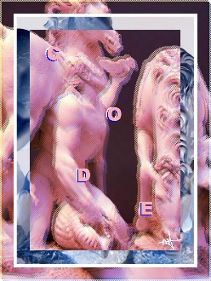
"Dissonance" by Mera Alfawares
Freshman; Computer Science major, Graphic Arts Technology minor
Artist's statement: "To start the project I planned out how I wanted the final product to look, and I may have set my standards too high and so the most challenging part was to create a program that would meet the standards of what I had in mind. I definitely had to compromise a few things. Sometimes you just have to let JES win. Though it was very exciting to see the final product (and to actually submit it on time!), the most rewarding part of the project was whenever a section of my code—that repeatedly gave me errors—would finally work."

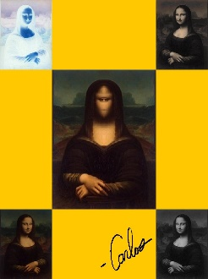
"Mono Lisa" by Carlos Fernandez
Senior; Actuarial Science major
Artist's statement: "The code to get the central image was pretty difficult, so that the face was mirrored, but the hands at the bottom were not. The most rewarding part was seeing it come together, bit by bit. Each task provided different challenges."

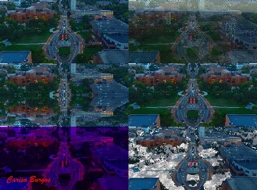
"Cardinal Seasons" by Carisa Burgos
Senior; Actuarial Science and Mathematical Economics majors, Foundations of Business minor
Artist's statement: "Finding the right picture size to expose enough elements and make the picture worth looking at was challenging. Seeing how all the functions work together and with the picture was rewarding. I enjoyed messing around with the functions to see how each one would affect the picture and how to modify them to get it to do what I want."

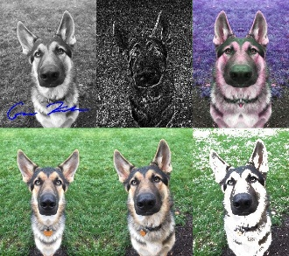
"George the German Shepherd" by Gavin Kaehr
Senior; Actuarial Science and Mathematical Economics majors, Foundations of Business minor
Artist's statement: "The most challenge part of the collage was trying to create my own modification by changing George's tan fur to white fur. The most rewarding part of the collage creation was knowing I am very familiar now with JES functions."

Section 4 Instructor: Karl Mesarosh (continued)

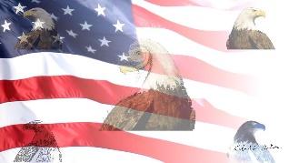
"’Merica" by Gabe Lindholm
Junior; Actuarial Science major, Computer Science minor
Artist's statement: "Deciding what I was going to do with the eagle in the center was the toughest. I wanted to do rotations of π/6 all copied on top of each other but wound up doing a swirl instead as I couldn’t get the rotations to not look pixelated. I am proud of the functions I created myself. It felt good to have a picture of what I wanted in my head and then to be able to produce it on my own."

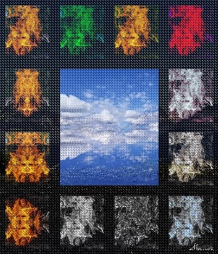
"The ring of fire" by Marcus Weimer
Freshman; Finance major
Artist's statement: "Making the images fit on the canvas and keeping the code in order was very challenging. The finished product was rewarding… ‘Hard work always has pleasing results.’"

Section 5 Instructor: Karl Mesarosh

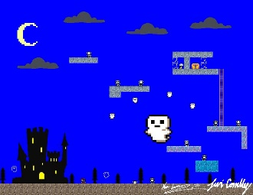
"Cursed Cauldrons" by Levi Connelly
Sophomore; Computer Science major
Artist's statement: "What I found most difficult was that not only did I want my picture to be reminiscent of a retro game (like the NES), but I also wanted my code to be reminiscent of the code they used in the cartridges. Now obviously I wasn't going to write this in assembly code because it was a Python assignment, but I took a lot of inspiration from tile and sprite placement and manipulation. This was a bit of an extra challenge for me. The most rewarding part was seeing it finished, and watching it all come together; in addition to this, I feel as though I've developed a greater understanding for Python in the process, even if a lot of it was JES." Artist credit: Katie Luzadder.

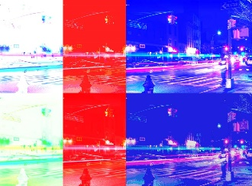
"Paris" by Sam Ditslear
Sophomore; Computer Science major
Artist's statement: "The most challenging part was finding the right picture to do it to. I did it to a picture of an owl first which is why in the coding it is owl.jpg. But i saw a picture of the city and I liked it a lot. The most rewarding part was when it came out the way I wanted. And I am actually going to change the colors to the French flag."

Section 5 Instructor: Karl Mesarosh (continued)

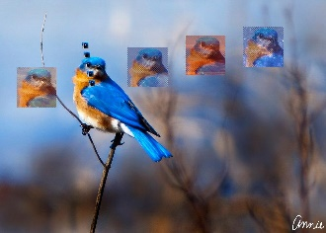
"Bird's Eye View" by Annie Peabody
Freshman; Computer Science major
Artist's statement: "The most challenging part of the collage was doing all the math to get all the crop area to be where I wanted them to be. The most rewarding part was having everything work out like I wanted it to in order to make a slightly surrealistic image."

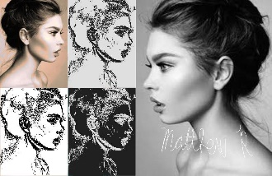
"Shattered Reflections" by Matthew Rhinehart
Freshman; Computer Science major
Artist's statement: "The most challenging part of this project was figuring out a way to copy the picture onto the canvas backwards and be able to use both the forwards and backwards picture. The most rewarding part of this project was when all the code finally came together and showed the final product, which I had not quite imagined until that happened. It was cool to see everything come together so well."

